Question 1: Top Categories by Total Price
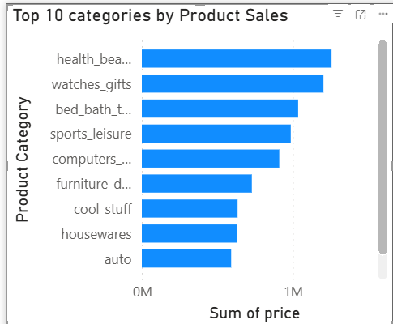
Explanation:
This chart shows the top 10 product categories based on total sales value.
It helps identify the most revenue-generating categories.

Question 2: Delayed Orders Analysis
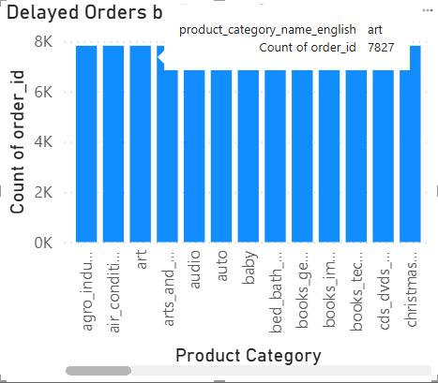
Explanation:
This visualization shows the number of delayed orders across product categories.
It helps understand delivery performance and delays.
Question 3: Monthly Comparison of Delayed vs On-Time Orders
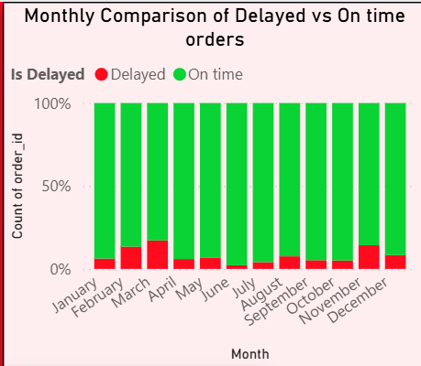
Explanation:
This chart compares delayed and on-time orders for each month,
highlighting trends in delivery performance over time.

Question 4: Payment Method Analysis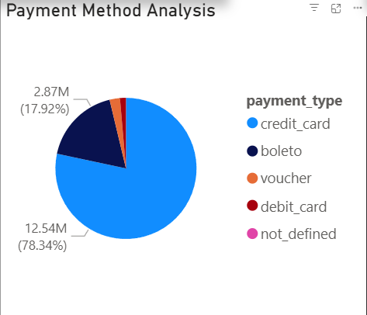
Explanation:
This chart represents the distribution of payment methods used by customers,
showing the most preferred payment options.

Question 5: Product Rating Analysis
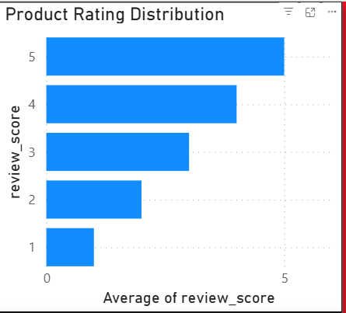

Explanation:
This visualization shows the distribution of product ratings,
highlighting customer satisfaction levels.

Question 6: State-wise Sales Analysis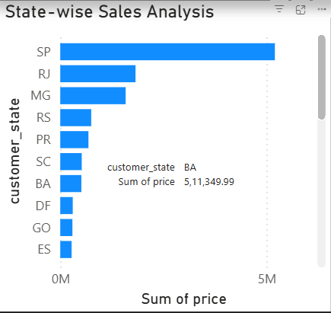

Explanation:
This chart displays sales performance across different states,
helping identify high and low performing regions.

Question 7: Seasonal Sales Patterns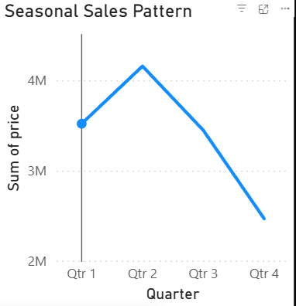

Explanation:
This chart shows seasonal sales trends on a quarterly basis,
helping identify peak and low sales periods.

Question 8: Revenue Analysis
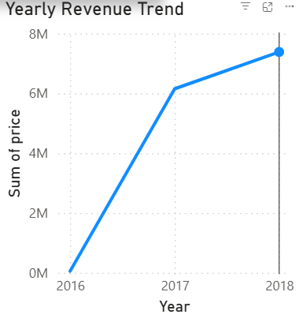

Explanation:
This visualization shows total yearly revenue trends,
helping analyze growth patterns over time.

